**GIT AND GITHUB BASICS**

-------------------Setting up git : this is on git bash not required necessarily we can use VS code-----------

C:\Users\Adhithi C Iyer>git config --global user.name "Adhithi02"

C:\Users\Adhithi C Iyer>git config --global user.email "adhithiciyer@gmail.com"

C:\Users\Adhithi C Iyer>git config --list

diff.astextplain.textconv=astextplain

filter.lfs.clean=git-lfs clean -- %f

filter.lfs.smudge=git-lfs smudge -- %f

filter.lfs.process=git-lfs filter-process

filter.lfs.required=true

http.sslbackend=schannel

core.autocrlf=true

core.fscache=true

core.symlinks=false

pull.rebase=false

credential.helper=manager

credential.https://dev.azure.com.usehttppath=true

init.defaultbranch=master

user.name=Adhithi02

user.email=adhithiciyer@gmail.com

C:\Users\Adhithi C Iyer>

--------- When modifications are made locally but not changed on Github main-------------------------------

PS C:\Users\Adhithi C Iyer\Desktop\gitdemo\demo> git status

On branch main

Your branch is up to date with 'origin/main'.

nothing to commit, working tree clean

PS C:\Users\Adhithi C Iyer\Desktop\gitdemo\demo> git status

On branch main

Your branch is up to date with 'origin/main'.

Changes not staged for commit:

(use "git add <file>..." to update what will be committed)

(use "git restore <file>..." to discard changes in working directory)

modified: README.md

no changes added to commit (use "git add" and/or "git commit -a")

PS C:\Users\Adhithi C Iyer\Desktop\gitdemo\demo>

-----------adding(staging the code), then committing the code------------------------------------------------------

PS C:\Users\Adhithi C Iyer\Desktop\gitdemo\demo> git add . // only for one file then syntax is git add<file name>

PS C:\Users\Adhithi C Iyer\Desktop\gitdemo\demo> git status

On branch main

Your branch is up to date with 'origin/main'.

Changes to be committed:

(use "git restore --staged <file>..." to unstage)

modified: README.md

new file: index.html

PS C:\Users\Adhithi C Iyer\Desktop\gitdemo\demo> git commit -m "basics

"

[main 790c354] basics

2 files changed, 2 insertions(+)

create mode 100644 index.html

PS C:\Users\Adhithi C Iyer\Desktop\gitdemo\demo> git status //checking the status after add and commit commands

On branch main

Your branch is ahead of 'origin/main' by 1 commit.

(use "git push" to publish your local commits) // means only present locally must be pushed to github to reflect changes in the repo on website

nothing to commit, working tree clean

PS C:\Users\Adhithi C Iyer\Desktop\gitdemo\demo>

--------------------------------push command--------------------------------------------------------------------------------PS C:\Users\Adhithi C Iyer\Desktop\gitdemo\demo> git push origin main

Enumerating objects: 6, done.

Counting objects: 100% (6/6), done.

Delta compression using up to 8 threads

Compressing objects: 100% (2/2), done.

Writing objects: 100% (4/4), 321 bytes | 107.00 KiB/s, done.

Total 4 (delta 0), reused 0 (delta 0), pack-reused 0 (from 0)

To https://github.com/Adhithi02/demo.git

755f840..790c354 main -> main

---------------------creating new folder and initializing it to git---------------------------------------------------------

PS C:\Users\Adhithi C Iyer\Desktop\gitdemo\demo> cd..

PS C:\Users\Adhithi C Iyer\Desktop\gitdemo> mkdir LocalRepo

Directory: C:\Users\Adhithi C Iyer\Desktop\gitdemo

Mode LastWriteTime Length Name

---- ------------- ------ ----

d----- 04-08-2025 11:10 LocalRepo

PS C:\Users\Adhithi C Iyer\Desktop\gitdemo> cd .\LocalRepo\

PS C:\Users\Adhithi C Iyer\Desktop\gitdemo\LocalRepo> ls -force

PS C:\Users\Adhithi C Iyer\Desktop\gitdemo\LocalRepo> git init

Initialized empty Git repository in C:/Users/Adhithi C Iyer/Desktop/gitdemo/LocalRepo/.git/

PS C:\Users\Adhithi C Iyer\Desktop\gitdemo\LocalRepo> ls -force

Directory: C:\Users\Adhithi C Iyer\Desktop\gitdemo\LocalRepo

Mode LastWriteTime Length Name

---- ------------- ------ ----

d--h-- 04-08-2025 11:11 .git

PS C:\Users\Adhithi C Iyer\Desktop\gitdemo\LocalRepo>

------------------Adding a remote repository onto git on which push operations are performed-------------

PS C:\Users\Adhithi C Iyer\Desktop\gitdemo\LocalRepo> git remote add origin <https://github.com/Adhithi02/LocalRepo.git//> last statement is the link

PS C:\Users\Adhithi C Iyer\Desktop\gitdemo\LocalRepo> git remote -v// to verify the remote repo

origin https://github.com/Adhithi02/LocalRepo.git (fetch)

origin https://github.com/Adhithi02/LocalRepo.git (push)

PS C:\Users\Adhithi C Iyer\Desktop\gitdemo\LocalRepo>

----------------------Changing the name of the branch-------------------------------------------------------------------

PS C:\Users\Adhithi C Iyer\Desktop\gitdemo\LocalRepo> git branch

* master

PS C:\Users\Adhithi C Iyer\Desktop\gitdemo\LocalRepo> git branch -M main

PS C:\Users\Adhithi C Iyer\Desktop\gitdemo\LocalRepo> git branch

* main

PS C:\Users\Adhithi C Iyer\Desktop\gitdemo\LocalRepo>

When I want to use the same project for a long time use this command the just use git push rest of the time

PS C:\Users\Adhithi C Iyer\Desktop\gitdemo\LocalRepo> git push -u origin main

Enumerating objects: 4, done.

Counting objects: 100% (4/4), done.

Delta compression using up to 8 threads

Compressing objects: 100% (2/2), done.

Writing objects: 100% (4/4), 304 bytes | 152.00 KiB/s, done.

Total 4 (delta 0), reused 0 (delta 0), pack-reused 0 (from 0)

To https://github.com/Adhithi02/LocalRepo.git

* [new branch] main -> main

branch 'main' set up to track 'origin/main'.

And that’s it from next time this is it  
PS C:\Users\Adhithi C Iyer\Desktop\gitdemo\LocalRepo> git add .

PS C:\Users\Adhithi C Iyer\Desktop\gitdemo\LocalRepo> git commit -m "readme file"

[main b582632] readme file

1 file changed, 1 insertion(+)

create mode 100644 README.md

PS C:\Users\Adhithi C Iyer\Desktop\gitdemo\LocalRepo> git push

Enumerating objects: 4, done.

Counting objects: 100% (4/4), done.

Delta compression using up to 8 threads

Compressing objects: 100% (2/2), done.

Writing objects: 100% (3/3), 331 bytes | 165.00 KiB/s, done.

Total 3 (delta 0), reused 0 (delta 0), pack-reused 0 (from 0)

To https://github.com/Adhithi02/LocalRepo.git

79eb4b8..b582632 main -> main

PS C:\Users\Adhithi C Iyer\Desktop\gitdemo\LocalRepo>

-----------------------------Branch Commands--------------------------------------------------------------------------------

PS C:\Users\Adhithi C Iyer\Desktop\gitdemo\LocalRepo> git branch

* main

PS C:\Users\Adhithi C Iyer\Desktop\gitdemo\LocalRepo> git checkout -b feature1

Switched to a new branch 'feature1'

PS C:\Users\Adhithi C Iyer\Desktop\gitdemo\LocalRepo> git branch

* feature1

main

PS C:\Users\Adhithi C Iyer\Desktop\gitdemo\LocalRepo> git checkout main

Switched to branch 'main'

Your branch is up to date with 'origin/main'.

PS C:\Users\Adhithi C Iyer\Desktop\gitdemo\LocalRepo> git branch

feature1

* main

PS C:\Users\Adhithi C Iyer\Desktop\gitdemo\LocalRepo> git checkout feature1

Switched to branch 'feature1'

PS C:\Users\Adhithi C Iyer\Desktop\gitdemo\LocalRepo> git checkout -b feature2

Switched to a new branch 'feature2'

PS C:\Users\Adhithi C Iyer\Desktop\gitdemo\LocalRepo> git branch

feature1

* feature2

main

PS C:\Users\Adhithi C Iyer\Desktop\gitdemo\LocalRepo> git branch -d feature2

error: cannot delete branch 'feature2' used by worktree at 'C:/Users/Adhithi C Iyer/Desktop/gitdemo/LocalRepo' //here you cannot delete a branch if you are already there in the branch // then follow the below

PS C:\Users\Adhithi C Iyer\Desktop\gitdemo\LocalRepo> git checkout main

Switched to branch 'main'

Your branch is up to date with 'origin/main'.

PS C:\Users\Adhithi C Iyer\Desktop\gitdemo\LocalRepo> git branch

feature1

feature2

* main

PS C:\Users\Adhithi C Iyer\Desktop\gitdemo\LocalRepo> git branch -d feature2

Deleted branch feature2 (was b582632).

----------------Adding new Features to a new branch-------------------------------------------------------------------

PS C:\Users\Adhithi C Iyer\Desktop\gitdemo\LocalRepo> git checkout feature1

Switched to branch 'feature1'

PS C:\Users\Adhithi C Iyer\Desktop\gitdemo\LocalRepo> git branch

* feature1

main

PS C:\Users\Adhithi C Iyer\Desktop\gitdemo\LocalRepo> git status

On branch feature1

Changes not staged for commit:

(use "git add <file>..." to update what will be committed)

(use "git restore <file>..." to discard changes in working directory)

modified: index.html

no changes added to commit (use "git add" and/or "git commit -a")

PS C:\Users\Adhithi C Iyer\Desktop\gitdemo\LocalRepo> git add .

PS C:\Users\Adhithi C Iyer\Desktop\gitdemo\LocalRepo> git commit -m "New feature"

[feature1 f8461bc] New feature

1 file changed, 2 insertions(+), 1 deletion(-)

PS C:\Users\Adhithi C Iyer\Desktop\gitdemo\LocalRepo> git status

On branch feature1

nothing to commit, working tree clean

PS C:\Users\Adhithi C Iyer\Desktop\gitdemo\LocalRepo> git checkout main

Switched to branch 'main'

Your branch is up to date with 'origin/main'.

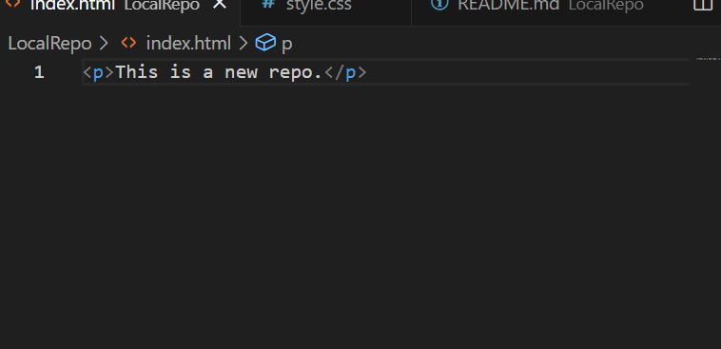

PS C:\Users\Adhithi C Iyer\Desktop\gitdemo\LocalRepo> git checkout feature1

Switched to branch 'feature1'

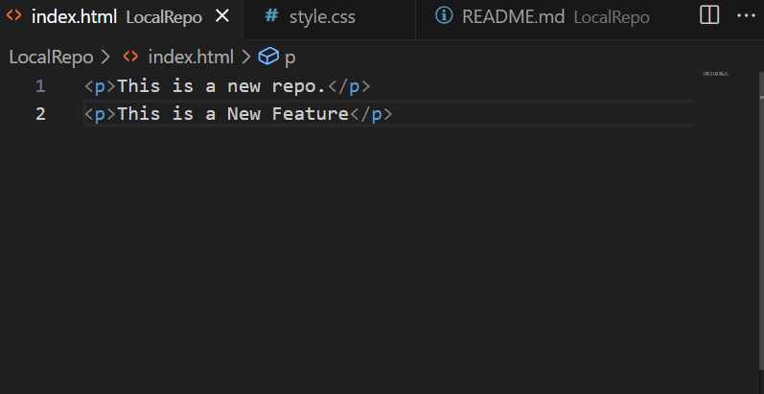

--------------------------------------Pushing onto the new branch---------------------------------------------------------

PS C:\Users\Adhithi C Iyer\Desktop\gitdemo\LocalRepo> git branch

* feature1

main

PS C:\Users\Adhithi C Iyer\Desktop\gitdemo\LocalRepo> git push origin feature1

Enumerating objects: 5, done.

Counting objects: 100% (5/5), done.

Delta compression using up to 8 threads

Compressing objects: 100% (3/3), done.

Writing objects: 100% (3/3), 351 bytes | 351.00 KiB/s, done.

Total 3 (delta 0), reused 0 (delta 0), pack-reused 0 (from 0)

remote:

remote: Create a pull request for 'feature1' on GitHub by visiting:

remote: https://github.com/Adhithi02/LocalRepo/pull/new/feature1

remote:

To https://github.com/Adhithi02/LocalRepo.git

* [new branch] feature1 -> feature1

------------------------------------merging the branches---------------------------------------------------------------------

WAY -1

PS C:\Users\Adhithi C Iyer\Desktop\gitdemo\LocalRepo> git branch

* feature1

main

PS C:\Users\Adhithi C Iyer\Desktop\gitdemo\LocalRepo> git diff main

diff --git a/index.html b/index.html

index df8d7c3..7df5b38 100644

--- a/index.html

+++ b/index.html

@@ -1 +1,2 @@

-<p>This is a new repo.</p>

\ No newline at end of file

+<p>This is a new repo.</p>

+<p>This is a New Feature</p>

\ No newline at end of file

PS C:\Users\Adhithi C Iyer\Desktop\gitdemo\LocalRepo>git merge main

WAY -2 // using github

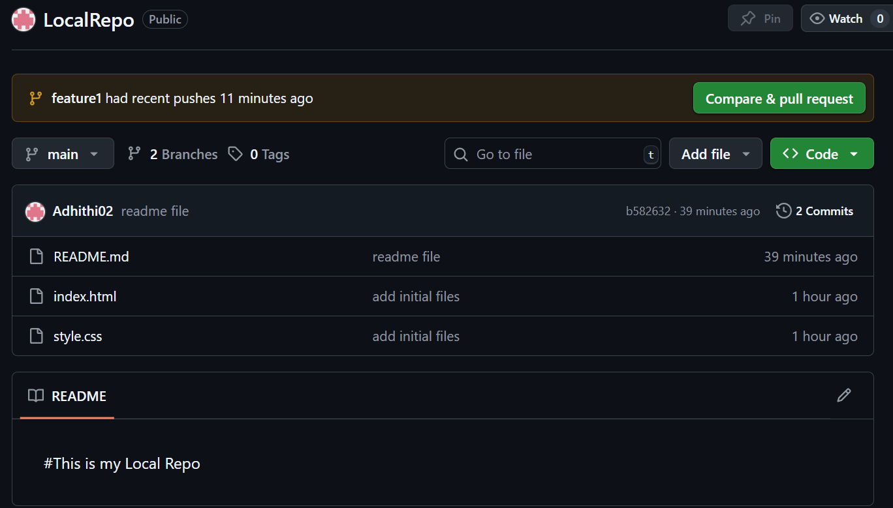

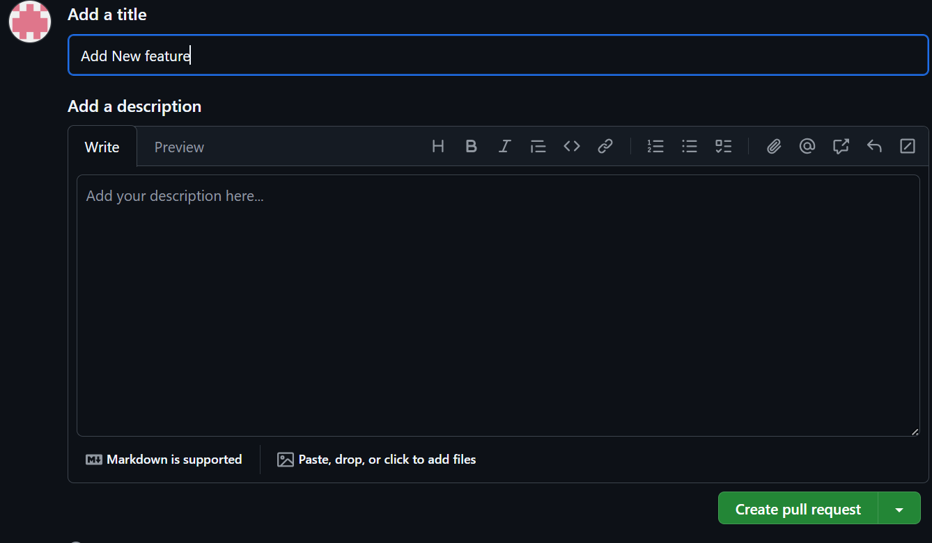



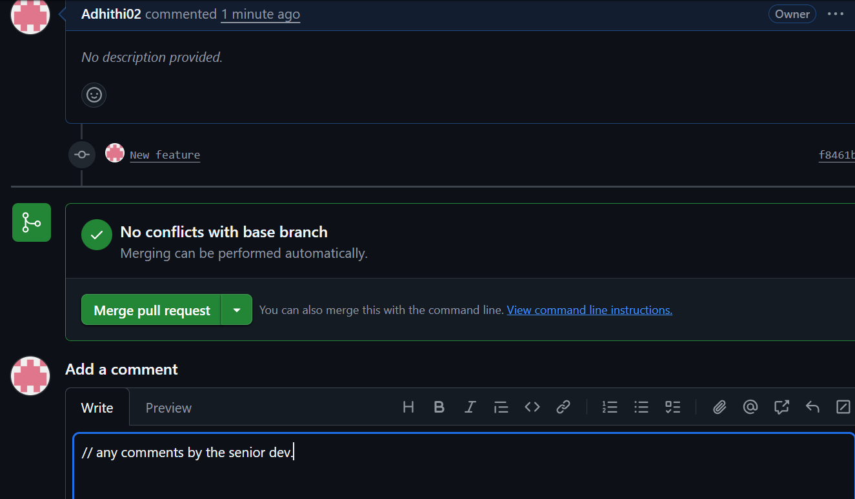

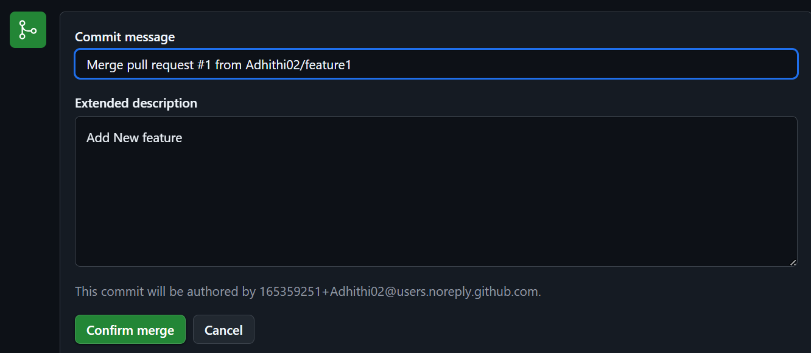

Hence finally , merged.

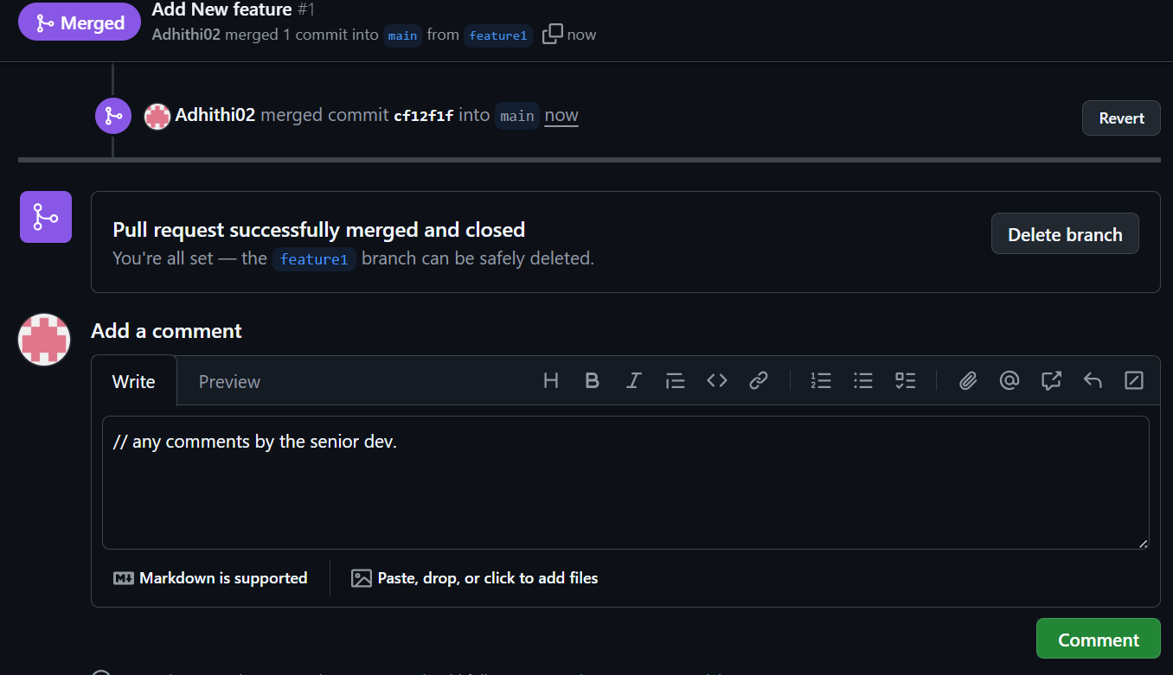

-------------PULL COMMANDS TO RESTORE UPDATES FROM REMOTE REPO TO LOCAL REPO----------------

PS C:\Users\Adhithi C Iyer\Desktop\gitdemo\LocalRepo> git pull origin main

remote: Enumerating objects: 1, done.

remote: Counting objects: 100% (1/1), done.

remote: Total 1 (delta 0), reused 0 (delta 0), pack-reused 0 (from 0)

Unpacking objects: 100% (1/1), 898 bytes | 19.00 KiB/s, done.

From https://github.com/Adhithi02/LocalRepo

* branch main -> FETCH_HEAD

b582632..cf12f1f main -> origin/main

Updating b582632..cf12f1f

Fast-forward

index.html | 3 ++-

1 file changed, 2 insertions(+), 1 deletion(-)

----------------------------------------------resolving merge conflicts-------------------------------------------------------

Let’s make some changes in index.html file, while in main branch  
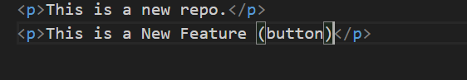



Now, add and commit then checkout to the feature1 branch  
PS C:\Users\Adhithi C Iyer\Desktop\gitdemo\LocalRepo> git add .

PS C:\Users\Adhithi C Iyer\Desktop\gitdemo\LocalRepo> git commit -m "Add button"

[main ea3026a] Add button

1 file changed, 1 insertion(+), 1 deletion(-)

PS C:\Users\Adhithi C Iyer\Desktop\gitdemo\LocalRepo> git checkout feature1

Switched to branch 'feature1'

Then add some new feature into the index.html file  
something like this,  
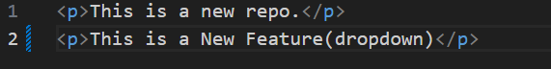



Now add and commit the feature onto the branch feature1  
PS C:\Users\Adhithi C Iyer\Desktop\gitdemo\LocalRepo> git branch



* feature1

main

PS C:\Users\Adhithi C Iyer\Desktop\gitdemo\LocalRepo> git add .

PS C:\Users\Adhithi C Iyer\Desktop\gitdemo\LocalRepo> git commit -m "Add dropdown"

[feature1 a5ccab4] Add dropdown

1 file changed, 1 insertion(+), 1 deletion(-)

Now we can see that there are differences in both branches and changes have been made in the same file

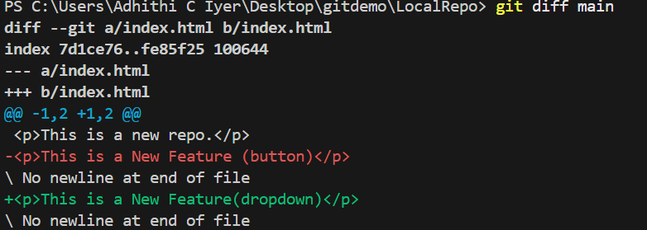

Now to merge we can use two ways as mentioned above, moving on further with Command Line git merge method  
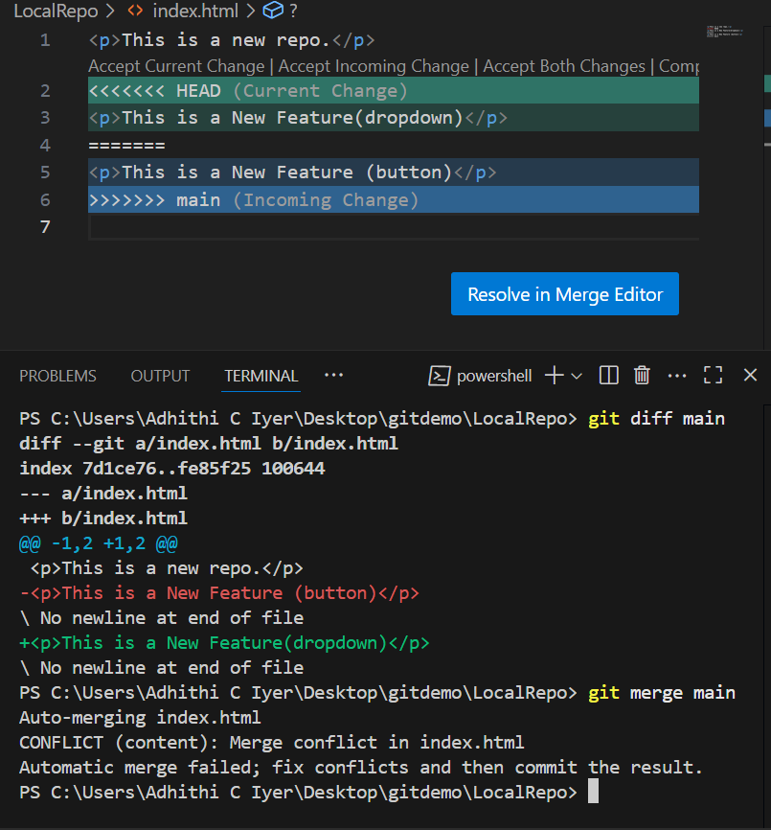



For instance we choose to keep both the features, Then follow this  
PS C:\Users\Adhithi C Iyer\Desktop\gitdemo\LocalRepo> git add .

PS C:\Users\Adhithi C Iyer\Desktop\gitdemo\LocalRepo> git commit -m "Add both the features"

[feature1 3d9b8e4] Add both the features

PS C:\Users\Adhithi C Iyer\Desktop\gitdemo\LocalRepo> git status

On branch feature1

nothing to commit, working tree clean

PS C:\Users\Adhithi C Iyer\Desktop\gitdemo\LocalRepo> git diff main

diff --git a/index.html b/index.html

index 7d1ce76..167ffef 100644

--- a/index.html

+++ b/index.html

@@ -1,2 +1,3 @@

<p>This is a new repo.</p>

-<p>This is a New Feature (button)</p>

\ No newline at end of file

+<p>This is a New Feature(dropdown)</p>

+<p>This is a New Feature (button)</p>

PS C:\Users\Adhithi C Iyer\Desktop\gitdemo\LocalRepo> git checkout main

Switched to branch 'main'

Your branch is ahead of 'origin/main' by 1 commit.

(use "git push" to publish your local commits)

//here we can see the main branch doesn’t have both the features hence we merge

PS C:\Users\Adhithi C Iyer\Desktop\gitdemo\LocalRepo> git merge feature1

Updating ea3026a..3d9b8e4

Fast-forward

index.html | 3 ++-

1 file changed, 2 insertions(+), 1 deletion(-)

Then push the changes made,

PS C:\Users\Adhithi C Iyer\Desktop\gitdemo\LocalRepo> git push

Enumerating objects: 11, done.

Counting objects: 100% (11/11), done.

Delta compression using up to 8 threads

Compressing objects: 100% (9/9), done.

Writing objects: 100% (9/9), 972 bytes | 243.00 KiB/s, done.

Total 9 (delta 2), reused 0 (delta 0), pack-reused 0 (from 0)

remote: Resolving deltas: 100% (2/2), done.

To https://github.com/Adhithi02/LocalRepo.git

cf12f1f..3d9b8e4 main -> main

-----------------------------------------------------UNDOING CHANGES------------------------------------------------------

1)STAGED CHANGES

For instance we delete the button feature in the idex.html file in main branch then,  
PS C:\Users\Adhithi C Iyer\Desktop\gitdemo\LocalRepo> git add .

PS C:\Users\Adhithi C Iyer\Desktop\gitdemo\LocalRepo> git status

On branch main

Your branch is up to date with 'origin/main'.

Changes to be committed:

(use "git restore --staged <file>..." to unstage)

modified: index.html

THEN,

PS C:\Users\Adhithi C Iyer\Desktop\gitdemo\LocalRepo> git reset index.html

Unstaged changes after reset:

M index.html

PS C:\Users\Adhithi C Iyer\Desktop\gitdemo\LocalRepo> git status

On branch main

Your branch is up to date with 'origin/main'.

Changes not staged for commit:

(use "git add <file>..." to update what will be committed)

(use "git restore <file>..." to discard changes in working directory)

modified: index.html

no changes added to commit (use "git add" and/or "git commit -a")

2)COMMITTED CHANGES(single or multiple commits)  
PS C:\Users\Adhithi C Iyer\Desktop\gitdemo\LocalRepo> git add .

PS C:\Users\Adhithi C Iyer\Desktop\gitdemo\LocalRepo> git commit -m "delete button"

[main 137b6be] delete button

1 file changed, 1 insertion(+), 1 deletion(-)

PS C:\Users\Adhithi C Iyer\Desktop\gitdemo\LocalRepo> git status

On branch main

Your branch is ahead of 'origin/main' by 1 commit.//says its still there on remote repo/github

(use "git push" to publish your local commits)

nothing to commit, working tree clean

Then

PS C:\Users\Adhithi C Iyer\Desktop\gitdemo\LocalRepo> git reset HEAD~1// for multiple commit changes use git reset <-commit has-> which you can get from git log  
or use git reset –hard <-commit hash->

Unstaged changes after reset:

M index.html

git log: to check all the commits

PS C:\Users\Adhithi C Iyer\Desktop\gitdemo\LocalRepo> git log

commit 3d9b8e453a92345d8b67fd8bffd3b6188c7ecd37 (HEAD -> main, origin/main, feature1)

Merge: a5ccab4 ea3026a

Author: Adhithi02 <adhithiciyer@gmail.com>

Date: Mon Aug 4 13:09:27 2025 +0530

Add both the features

commit a5ccab444d1a492f9d41bc82a0e65c9477ca7776

Author: Adhithi02 <adhithiciyer@gmail.com>

Date: Mon Aug 4 12:48:45 2025 +0530

Add dropdown

commit ea3026ace1e9b3849d46c180c9250a29ee8bec5d

Author: Adhithi02 <adhithiciyer@gmail.com>